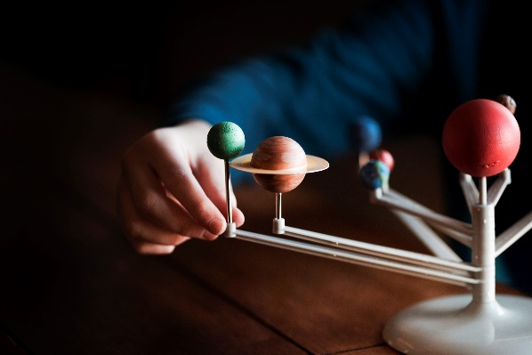**The Galileo Affair**

Who’s to Blame?

A Brief Overview

The Galileo Affair is one of the easiest and commonest historical events people use to take a cheapshot at Catholicism. As always, history shows the truth to be much more nuanced.

## **First, Let’s Bust Some Myths**

***He invented the telescope.***

* The Dutch eyeglass maker Hans Lippershey invented the telescope at sought a patent for it in 1608. Galileo refined the telescope and created a model that magnified 20x.

***He was imprisoned and tortured for saying Earth went around the Sun.***

* He was threatened with torture during his trial before the Roman Inquisition.
* He was placed under comfortable house arrest.
* He was punished for asserting heliocentrism as fact rather than hypothesis, for usurping the theologians’ role, and for mocking the pope.

***He proved Earth goes around the Sun.***

* The scientific method is incapable of proving because of the type of reasoning it uses. The most it can generate are theories: hypotheses shown by repeated experimentation to be very likely to be true. Gravity, natural selection, and the Big Bang are scientific theories.
* Galileo’s proofs were far from watertight.

***He was an innocent martyr for science against an anti-science Church.***

* The Catholic Church created the environment that made the Scientific Revolution possible.

## A diagram of the Ptolemaic system: concentric circular orbits: Earth at the center, then the Moon, Venus, the Sun, Mars, Jupiter, Saturn, the stars**The Ptolemaic System**

In use during the Middle Ages, the Ptolemaic system goes back to Aristotle and Ptolemy. It is the cosmology of *The Divine Comedy*.

Key Features

* Geocentrism (with Earth at the center)
* Spherical bodies—including Earth. Everyone knew Earth was round.
* Circular orbits (current theories understand them to be elliptical.)
* Constant orbital speeds (current models of gravity speak of rates of acceleration.)

## **Nicolaus Copernicus (1473–1543)**

Copernicus was a Polish Renaissance mathematician, astronomer, and Catholic canon who developed a heliocentric (with the sun at the center) model of the universe.

1512–1517: the Fifth Lateran Council consulted him on calendar reforms.

1543: At the urging of his friends, including several prelates, Copernicus published *Six Books on the Revolutions of Celestial Orbits*.

* Key difference from the Ptolemaic system: heliocentrism
* Protestants attacked it for contradicting Scripture, but it received no formal Catholic censure until the time of Galileo.

## **Galileo Galilei (1564–1642)**

An Italian astronomer, physicist, and engineer

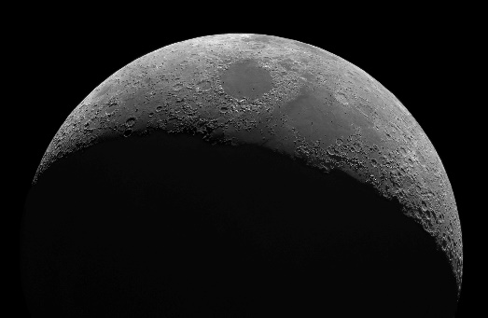He made several observations with his telescope that helped to undermine the Ptolemaic system. If Ptolemy didn’t know about these, what else didn’t he know?

* Jupiter’s 4 Galilean Moons (Ganymede, Calisto, Io, Europa): first extraterrestrial moons ever discovered
  + Showed that moving planets don’t leave smaller satellites behind. An objection to heliocentrism was that Earth would leave the Moon behind.
* Sunspots and mountains on the moon contradicted the belief that heavenly bodies were smooth, perfect spheres.
* Saturn’s rings, though he thought they were planets
* The phases of Venus, theorized by Copernicus and impossible in the Ptolemaic system
* Neptune, though he thought it was a star, and it wasn’t officially discovered until 1846.

1610: Fr. Christopher Clavius (who headed the commission that created the Gregorian Calendar) wrote to tell Galileo that his fellow Jesuit astronomers had confirmed Galileo’s discoveries.

1611: Galileo went to Rome, where he was welcomed by both religious and secular figures.

1612: He published *Letters on the Sunspots*, espousing the Copernican system in print for the first time.

* One of his congratulators was Cardinal Maffeo Barberini, who later became Pope Urban VIII.
* Among other things, it ridiculed a Jesuit’s (to our knowledge correct) treatment of comets as heavenly bodies; Galileo said they were reflections on vapors rising from the earth.

1616: The Church told Galileo he was free to continue teaching Copernicanism as a hypothesis. The Church had no objection to the Copernican system as a theoretical model, as it accounted for many astronomical phenomena that other systems could not.

The problem was that Galileo believed his model to be fact but had no adequate proof. For example, he claimed tides to be evidence of Earth’s motion, though it had been known from antiquity that the Moon caused the tides. Nor could he explain the lack of parallax shifts in the stars—an ancient objection to heliocentrism: if Earth moves, why don’t the apparent positions of the stars?

He refused the proposed compromise to teach Copernicanism as a hypothesis until he could provide proof. Instead, he said Bible verses contradicting Copernicanism would have to be reinterpreted. Such an approach was nothing new; St. Augustine had articulated it centuries before. There was no fear of scientific truth, though such terminology did not yet exist: since God is the source of all truth, nothing He made discoverable to the human intellect would contradict Revelation. Cardinal Robert Bellarmine famously stated that theologians would indeed need to reinterpret Scriptural passages that seemed to contradict heliocentrism, were there solid scientific proof for the model. Galileo could provide no such proof, and he overstepped his bounds as an astronomer and usurped the role of the theologians, who were reluctant to set aside the literal meaning of Scripture in the face of Protestant accusations that the Catholic Church disregarded the Bible. Prior to the Reformation, academia had enjoyed more license than it must now do in the midst of interdenominational turmoil.

1632: Galileo published his *Dialogue on the Great World Systems*.

* This is what got him in trouble.
* He wrote it at the pope’s urging but ignored his instructions to present Copernicanism as a hypothesis. He had two philosophers argue for Copernicanism against a layman named Simplicio (“simpleton”), who argued for the Ptolemaic system. This is a strawman, putting the pope’s disclaimer in Simplicio’s mouth.

1633: The Church declared Galileo suspected of heresy and (perhaps unwisely) ordered him not to publish any more on Copernicanism.

* Heliocentrism was still not declared a heresy and never has been.
* The pope felt betrayed, but Galileo continued to blame Jesuits and university professors.

1633: He was called before the Roman Inquisition, forced to recant, and placed under comfortable house arrest. He was neither imprisoned nor tortured.

* While under house arrest, he published *Two New Sciences*, on kinematics and strength of materials—some of his finest work, which earned him the title of the father of modern physics.

1718: Lifting the Inquisition’s ban, permission was granted to publish his works, excluding the Dialogue.

1714: Pope Benedict XIV gave permission for the publication of Galileo’s complete works, including a slightly censored version of the Dialogue. Formal Church opposition to heliocentrism gradually disappeared until 1835.

1992: Pope John Paul II acknowledged the Church’s error in condemning Galileo and for not recognizing the distinction between the Bible and its interpretation.

## **Further Reading**

*The Discarded Image: an Introduction to Medieval and Renaissance Literature*, by C.S. Lewis

*How the Catholic Church Built Western Civilization*, by Thomas E. Woods, Jr.

*How the West Won*, by Rodney Stark